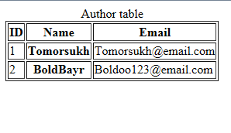

<!DOCTYPE html>

<html>

<head>

<title>Test 30 point</title>

</head>

<body>

<table border="1px">

<caption>Author table</caption>

<thead>

<tr>

<th id="n"> ID </th>

<th> Name </th>

<th> Email </th>

</th>

</thead>

<tbody>

<tr>

<td headers="n r1"> 1 </td>

<th id="r1"> Tomorsukh </th>

<td> Tomorsukh@email.com </td>

</th>

<tr>

<td headers="n r2"> 2 </td>

<th id="r2"> BoldBayr </th>

<td> Boldoo123@email.com </td>

</tr>

</tbody>

</table>

</body>

</html>